Introduction to MATLAB and Simulink
MATLAB (Matrix Laboratory) is a high-level programming language and environment designed for numerical computing, data analysis, and algorithm development. In the context of simulation, it serves as the "engine" that handles complex mathematical calculations.
Simulink is a graphical extension of MATLAB. Instead of writing lines of code, you use a Block Diagram environment to design and simulate systems.
- How it works: You drag "blocks" (which represent mathematical functions) onto a canvas and connect them with "lines" (which represent signals).
- Modeling Connection: When you run a simulation in Simulink, it uses MATLAB’s numerical solvers (like ode45) in the background to solve the differential equations represented by your diagram.

Basic Working in Simulation and Modeling
In simulation, the process follows a simple logic:
- Input: You define an input signal (like a Step or Sine wave).
- Processing: The signal passes through blocks like Integrators, Gains, and Summers that represent your differential equation.
- Output: The "solved" variable is sent to a Scope or Display so you can see how the system behaves over time.

Commonly Used Simulink Blocks
To simulate an analog computer, you will primarily use blocks from the Continuous and Math Operations libraries.
Block Name | Block Diagram | Function
Integrator | 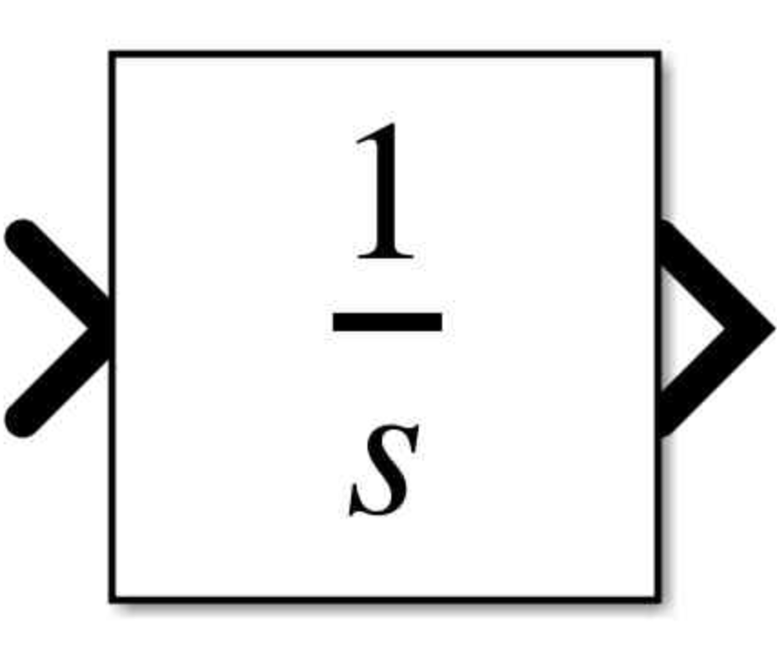 | Performs integration (int). It is the most important block for solving differential equations.
Gain | 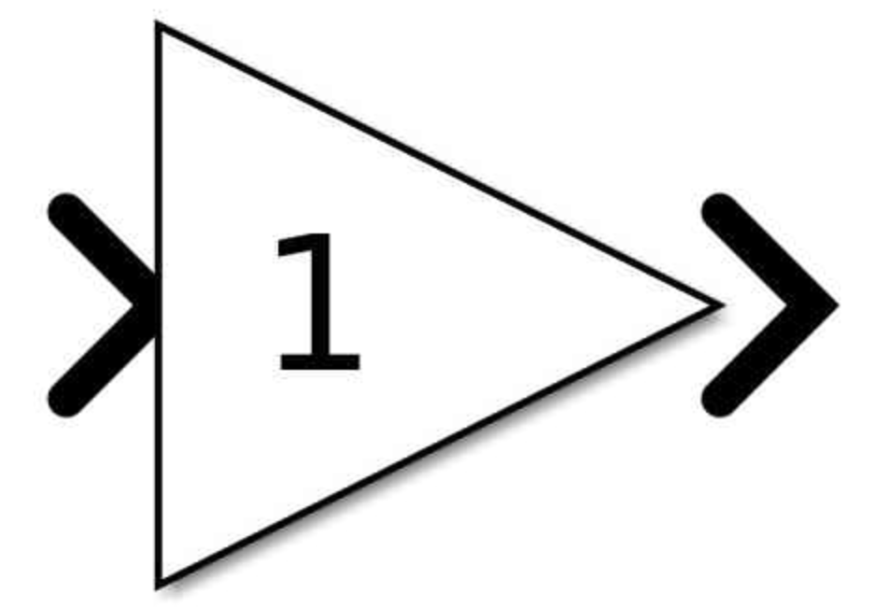 | Multiplies the input by a constant value (e.g., the coefficients in your equation).
Sum |  | Adds or subtracts multiple signals. You can change the signs (e.g., ++-) by double-clicking it.
Sine Wave | 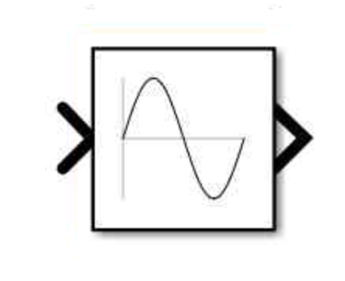 | Generates a sinusoidal signal (sin(x)). Used for equations 3, 4, and 5.
Constant | 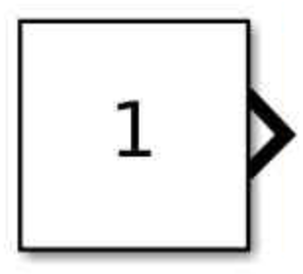 | Provides a fixed value (like the "1" in your first two equations).
Scope | 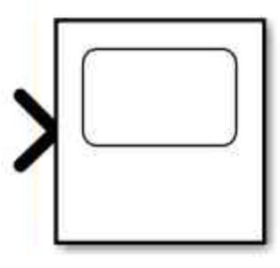 | Acts like a virtual oscilloscope to plot the output signal y(t) against time.
Trignometric Function | 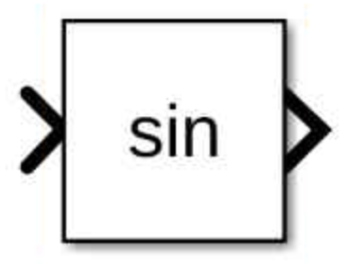 | Acts like a common mathematical operation such as sine, cosine, tangent, and their inverses to an input signal.
Mux | 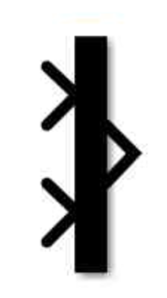 | Combines multiple signals into one line so you can view the input and output on the same Scope.

Why MATLAB and Simulink are Important to Study
- Model-Based Design: It allows you to build a "virtual prototype." Instead of building an expensive electrical circuit with physical op-amps and capacitors to solve a differential equation, you can simulate it first to see if the design works.
- Handling Complexity: Solving a second-order differential equation by hand is manageable, but real-world systems (like an aircraft’s flight control or an electric vehicle’s battery management) involve hundreds of variables. Simulink handles this complexity easily through its hierarchical block structure.
- Visualizing Abstract Concepts: Many differential equations describe motion or behavior that is hard to "see" in your head. Simulink's Scope block provides immediate visual feedback, showing exactly how a system responds to different inputs (like a sudden "step" change or a "sine" oscillation).
- Predictive Analysis: Engineers use these tools to predict how a system will behave under stress or varying conditions without the risk of damaging real equipment.
- Career Readiness: Proficiency in these tools is a highly sought-after skill in fields like Aerospace, Automotive, Robotics, and Power Systems.

